Air travel is safer than ever

Recent high-profile airline crashes are causing news outlets to push a false narrative that flying is not as safe as it used to be. Data shows that nothing can be further from the truth.

Thanks to new regulations such as ASAP (The Aviation Safety Action Program) and FOQA (The Flight Operational Quality Assurance program), data from anonymous airline staff and black boxes is being used to make air travel safer (Rolph, 2019). When comparing the two fifteen-year periods of 1985-1999 and 2000-2014, airline incidents are down 42% and fatalities are down 50%. Accidents are fewer and less fatal overall.

Figure Airline incidents in 1985-1999 compared to 2000-2014

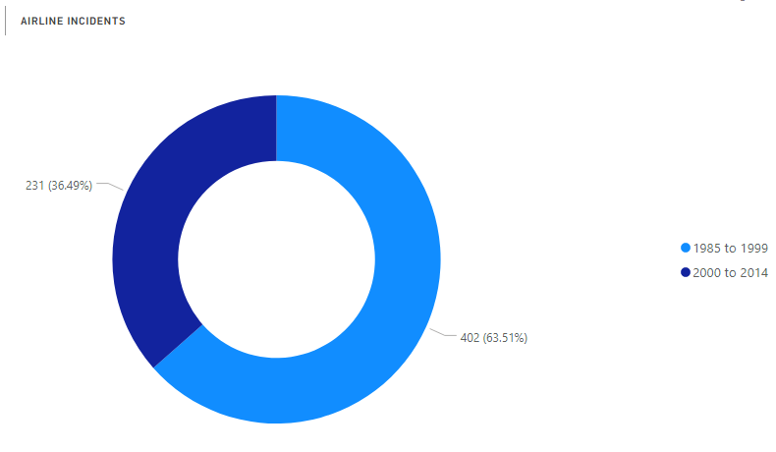

Looking at the entire history of air travel, fatalities started increasing in the 1950s with the advent of commercial airlines. More people flying means higher chance of incidents. We saw a spike in airline deaths in 1972 when 2,373 people perished in 72 crashes (The Year of Flying Dangerously: 1972, 2017). These tragedies occurred mostly with the Russian airline Aeroflot due to low safety standards. Since then we have seen a steady decrease in airline deaths as safety standards and regulations have improved. As of 2016, air travel is safer than it has ever been since the advent of commercial airlines.

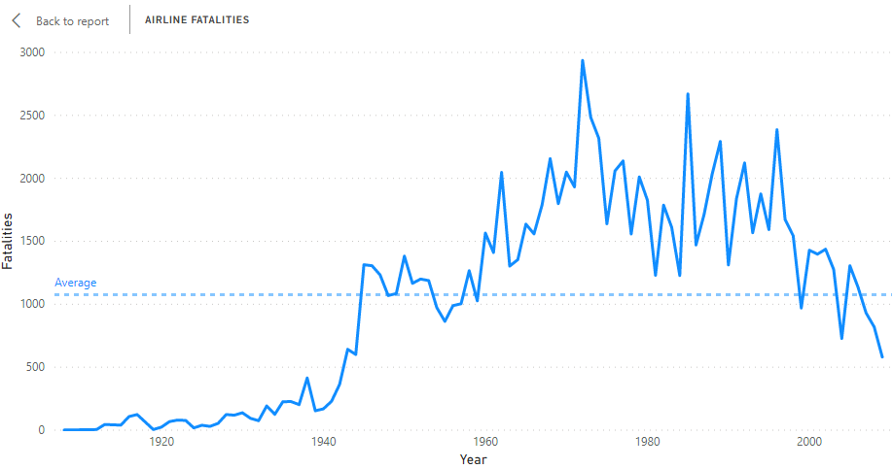

Figure History of Airline Fatalities

In 2017, zero deaths occurred on commercial airlines (Shepardson, 2018). In fact, the fatal accident rate for large commercial passenger flights is 1 per every 16 million flights. Compared to auto accidents killing 40,000 people in the US alone in the same year (Bomey, 2018).

With the Boeing 737 MAX aircraft being grounded due to faulty auto pilot issues, airline safety is in the news (Schaper, 2020). Based on the facts, though, and due to new safety regulations, it is now safer than ever to fly.

References

Airline Safety. (2018). Retrieved from <https://github.com/fivethirtyeight/data/tree/master/airline-safety>

Airplane Crashes Since 1908. (2016). Retrieved from <https://www.kaggle.com/saurograndi/airplane-crashes-since-1908/version/4#Airplane_Crashes_and_Fatalities_Since_1908.csv>

Bomey, N. (2018). U.S. Vehicle Deaths Topped 40,000 in 2017, National Safety Council Estimates. Retrieved May 3, 2020, from <https://www.usatoday.com/story/money/cars/2018/02/15/national-safety-council-traffic-deaths/340012002/>

Rolph, C. (2019). The Safety of Airlines. Retrieved May 3, 2020, from <https://blog.stafftraveler.com/aviation/airline-safety/>

Schaper, D. (2020). Boeing 737 Max May Stay Grounded into Summer. Retrieved May 3, 2020, from <https://www.npr.org/2020/01/21/798312515/boeing-737-max-may-stay-grounded-into-summer>

Shepardson, D. (2018). 2017 Safest Year on Record for Commercial Passenger Air Travel. Retrieved May 3, 2020, from <https://www.reuters.com/article/us-aviation-safety/2017-safest-year-on-record-for-commercial-passenger-air-travel-groups-idUSKBN1EQ17L>

System Total Operating Revenue. (n.d.). Retrieved from <http://web.mit.edu/airlinedata/www/Revenue&Related.html>

The Year of Flying Dangerously: 1972. (2017). Retrieved May 3, 2020, from <https://www.flightsafetyaustralia.com/2017/01/the-year-of-flying-dangerously-1972/>